**Bank Loan Report**

**KPI’s:**

**Total Loan Applications**

select count(id) as Total_Loan_Applications from financial_loan;

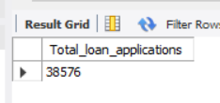

**MTD Loan Applications**

select count(id) as Total_MTD_Loan_Aplications from financial_loan

where month(issue_date)=12;



**PMTD Loan Applications**

select count(id) AS Total_PMTD_Loan_Applications FROM financial_loa

where month(issue_date) = 11;

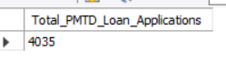

**Total Funded Amount**

Select sum(loan_amount) as Total_funded_Amount from financial_loan;

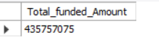

**MTD Total Funded Amount**

select sum(loan_amount) as Total_MTD_Loan_Amount from financial_loan

where Month(issue_date)=12;



**PMTD Total Funded Amount**

select sum(loan_amount) as Total_PMTD_Funded_Amount from financial_loan

where Month(issue_date)=11;



**Total Amount Received**

select sum(total_payment) as Total_Amount_Recieved from financial_loan;

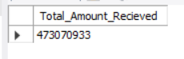

**MTD Total Amount Received**

select sum(total_payment) as Total_MTD_Amount_Recieved from financial_loan

where Month(issue_date)=12;



**PMTD Total Amount Received**

select sum(total_payment) as Total_PMTD_Amount_Recieved from financial_loan

where Month(issue_date)=11;



**Average Interest Rate**

select avg(int_rate)*100 as Avg_Int_rate from financial_loan;

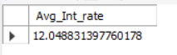

**MTD Average Interest Rate**

select avg(int_rate)*100 as MTD_Avg_Int_rate from financial_loan

where month(issue_date)=12;

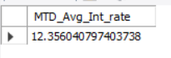

**PMTD Average Interest Rate**

select avg(int_rate)*100 as PMTD_Avg_Int_rate from financial_loan

where month(issue_date)=11;

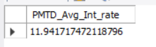

**Avg DTI**

select avg(dti)*100 as Avg_dti from financial_loan;

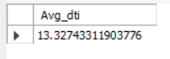

MTD Avg DTI

select avg(dti)*100 as MTD_Avg_dti from financial_loan

where month(issue_date)=12;



PMTD Avg DTI

select avg(dti)*100 as PMTD_Avg_dti from financial_loan

where month(issue_date)=11;

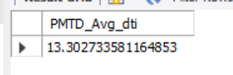

**GOOD LOAN ISSUED**

**Good Loan Percentage**

select (count(case when loan_status = "Fully Paid" or loan_status = "Current" then id end)*100.0)/count(id) as Good_loan_Percentage

from financial_loan;

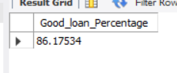

**Good Loan Applications**

select count(id) AS Good_Loan_Applications FROM financial_loan

where loan_status = "Fully Paid" OR loan_status = "Current";

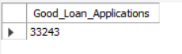

**Good Loan Funded Amount**

select sum(loan_amount) AS Good_loan_Funded_Amount FROM financial_loan

where loan_status = "Fully Paid" OR loan_status = "Current";



**Good Loan Amount Recieved**

select sum(total_payment) AS Good_loan_Amount_received FROM financial_loan

where loan_status = "Fully Paid" OR loan_status = "Current";



BAD LOAN ISSUED

**Bad Loan Percentage**

select (count(case when loan_status = "Charged Off" then id end)*100.0)/count(id) as Bad_loan_percentage from financial_loan;

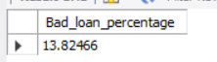

**Bad Loan Applications**

select count(id) AS Bad_Loan_Applications FROM financial_loan

where loan_status = "Charged Off";

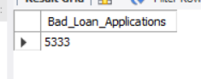

**Bad Loan Funded Amount**

select sum(loan_amount) AS Bad_loan_Funded_Amount FROM financial_loan

where loan_status = "Charged Off";

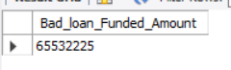

**Bad Loan Amount Recieved**

select sum(total_payment) AS Good_loan_Amount_received FROM financial_loan

where loan_status = "Charged Off";



**MONTH**

select month(issue_date) as month_number ,

monthname(issue_date) as Month_name,

count(id) as Total_loan_Applications,

sum(loan_amount) as Total_Funded_Amount,

sum(total_payment) as Total_Amount_Recieved

from financial_loan

group by 1,2

order by 1 asc;

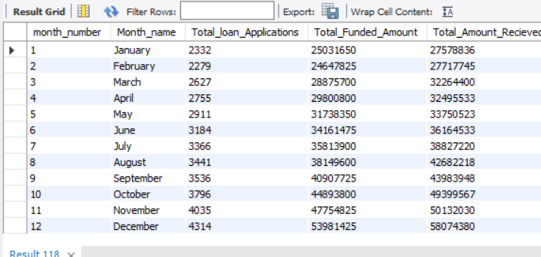

**STATE**

select address_state as state,

count(id) as Total_loan_Applications,

sum(loan_amount) as Total_Funded_Amount,

sum(total_payment) as Total_Amount_Recieved

from financial_loan

group by address_state,

order by address_state;

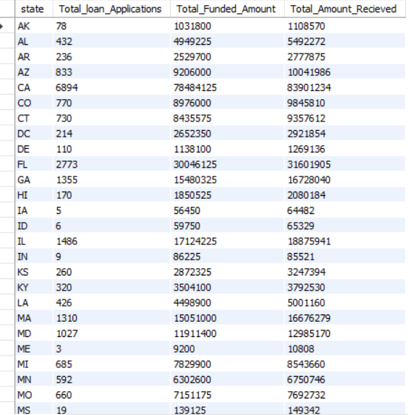

**TERM**

select term as Term,

count(id) as Total_loan_Applications,

sum(loan_amount) as Total_Funded_Amount,

sum(total_payment) as Total_Amount_Recieved

from financial_loan

group by term,

order by term;

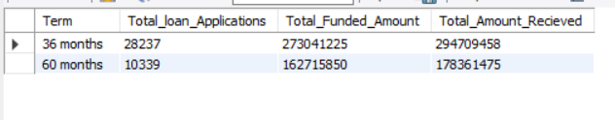

EMPLOYEE LENTH

select emp_length as Empployee_length,

count(id) as Total_loan_Applications,

sum(loan_amount) as Total_Funded_Amount,

sum(total_payment) as Total_Amount_Recieved

from financial_loan

group by emp_length

order by emp_length;

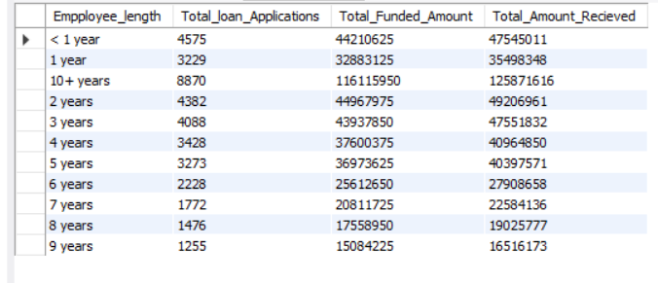

**PURPOSE**

select purpose as loan_purpose,

count(id) as Total_loan_Applications,

sum(loan_amount) as Total_Funded_Amount,

sum(total_payment) as Total_Amount_Recieved

from financial_loan

group by 1

order by 1;

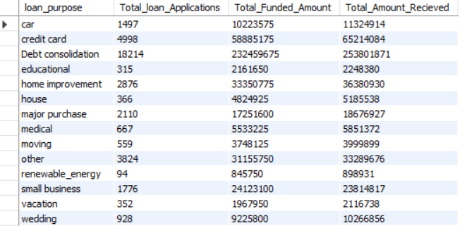

HOME OWNERSHIP

select home_ownership as Home,

count(id) as Total_loan_Applications,

sum(loan_amount) as Total_Funded_Amount,

sum(total_payment) as Total_Amount_Recieved

from financial_loan

group by 1

order by 1;

